**Employee Management System Endpoints**

* Role
  + Add new role (Only ADMIN role)
    - localhost:9090/role/addRole (POST request)
    - Authorization: Basic Auth (username: test1, password: welcome)
    - Body: {“role”: “REVIEWER”}
    - 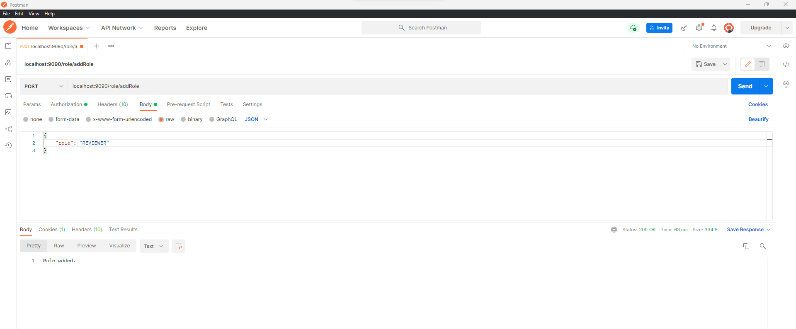
* User
  + Add new user (Only ADMIN role)
    - localhost:9090/user /addUser (POST request)
    - Authorization: Basic Auth (username: test1, password: welcome)
    - Body: {

    "username":"test3",

    "password”: “welcome",

    "roles”: [{

        "id":3,

        "name”: “REVIEWER "

    }]

}

* + - 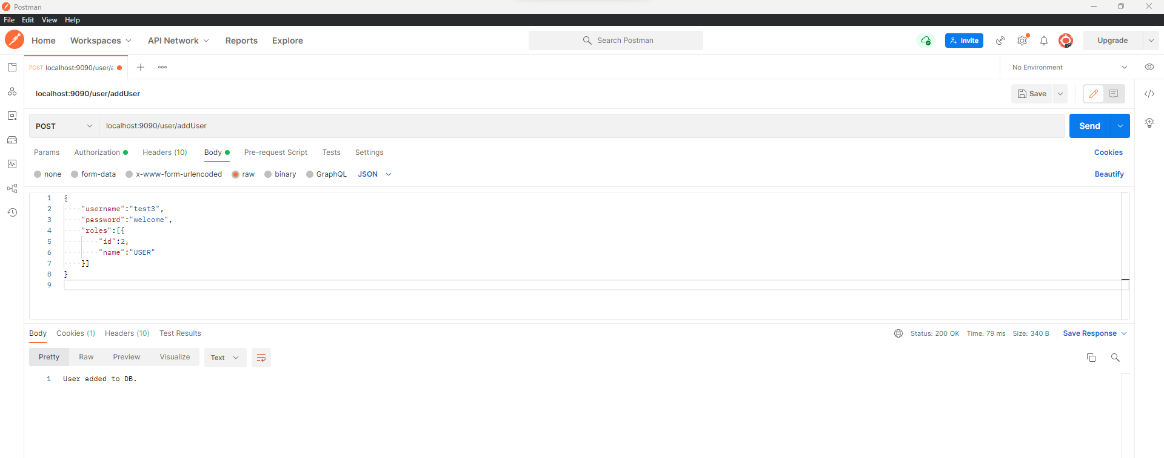
* Employee
  + Add new employee (Only ADMIN role)
    - localhost:9090/employee /addEmployee (POST request)
    - Authorization: Basic auth (username: test1, password: welcome)
    - Body: {

    "firstName": "Neal",

    "lastName": "Caffree",

    "email": "whitecollar@hotstar.com"

}

* + - 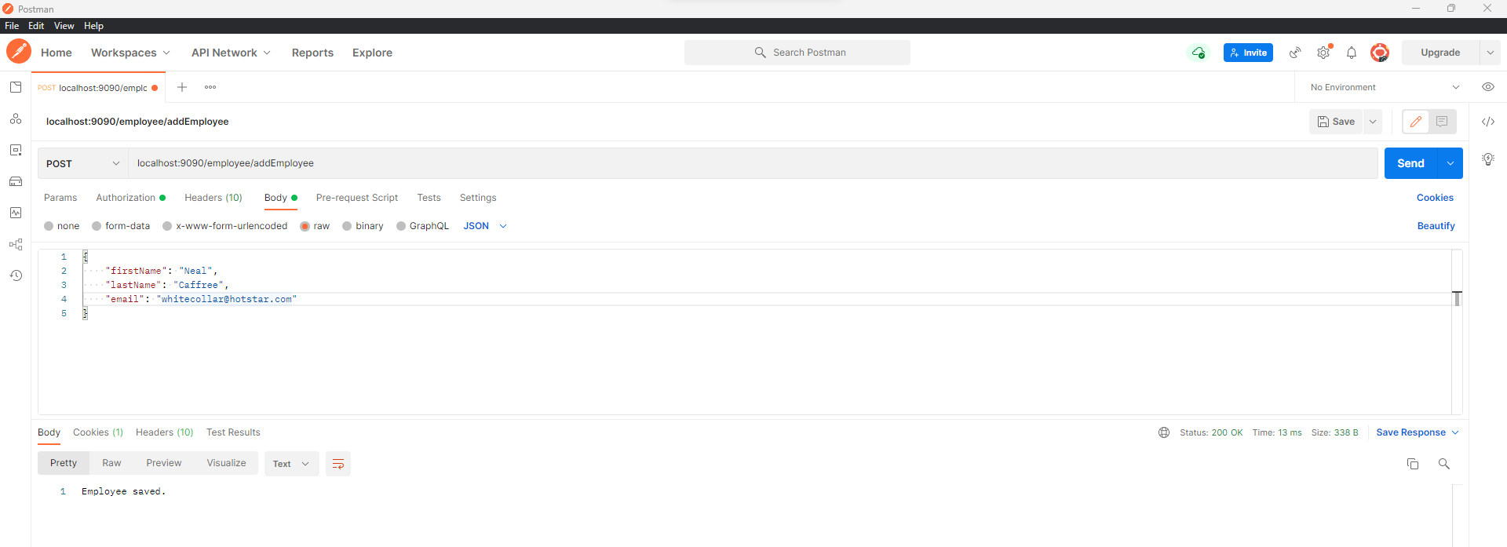
  + Update employee (Only ADMIN role)
    - localhost:9090/employee/updateEmployee (PUT request)
    - Authorization: Basic auth (username: test1, password: welcome)
    - Body: {

"id": 7,

"firstName": "Peter",

"lastName": "Burge",

"email": "whitecollar@hotstar.com"

}

* + - 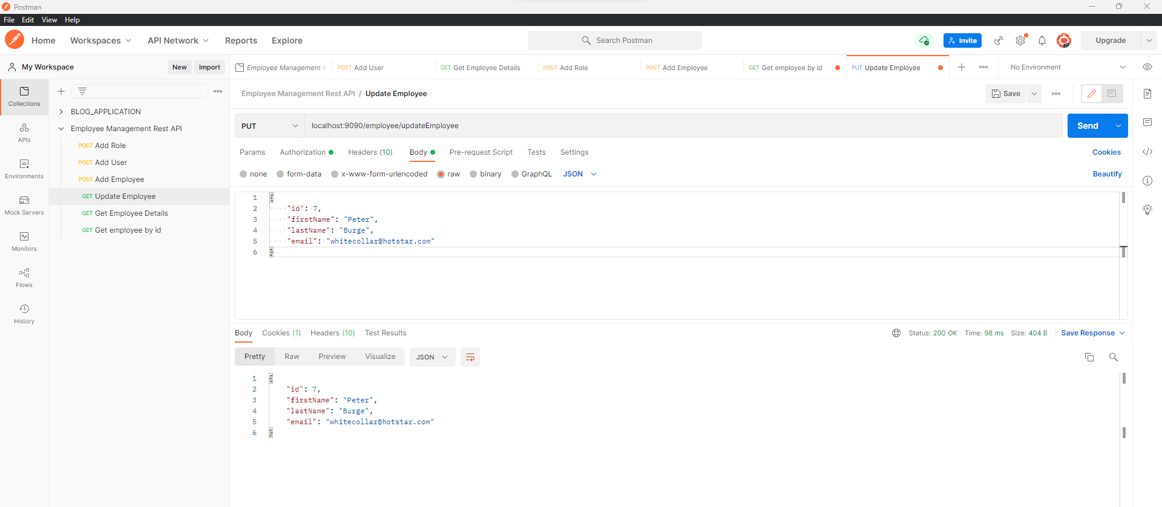
  + Delete employee (Only ADMIN role)
    - localhost:9090/employee/deleteEmployeeId/7 (Delete request)
    - Authorization: Basic auth (username: test1, password: welcome)
    - 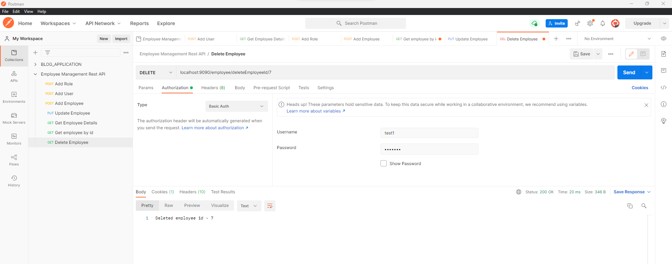
  + List all the employees (all users)
    - localhost:9090/employee/getAllEmployees (GET request)
    - Authorization: Basic auth (username: test3, password: welcome)
    - 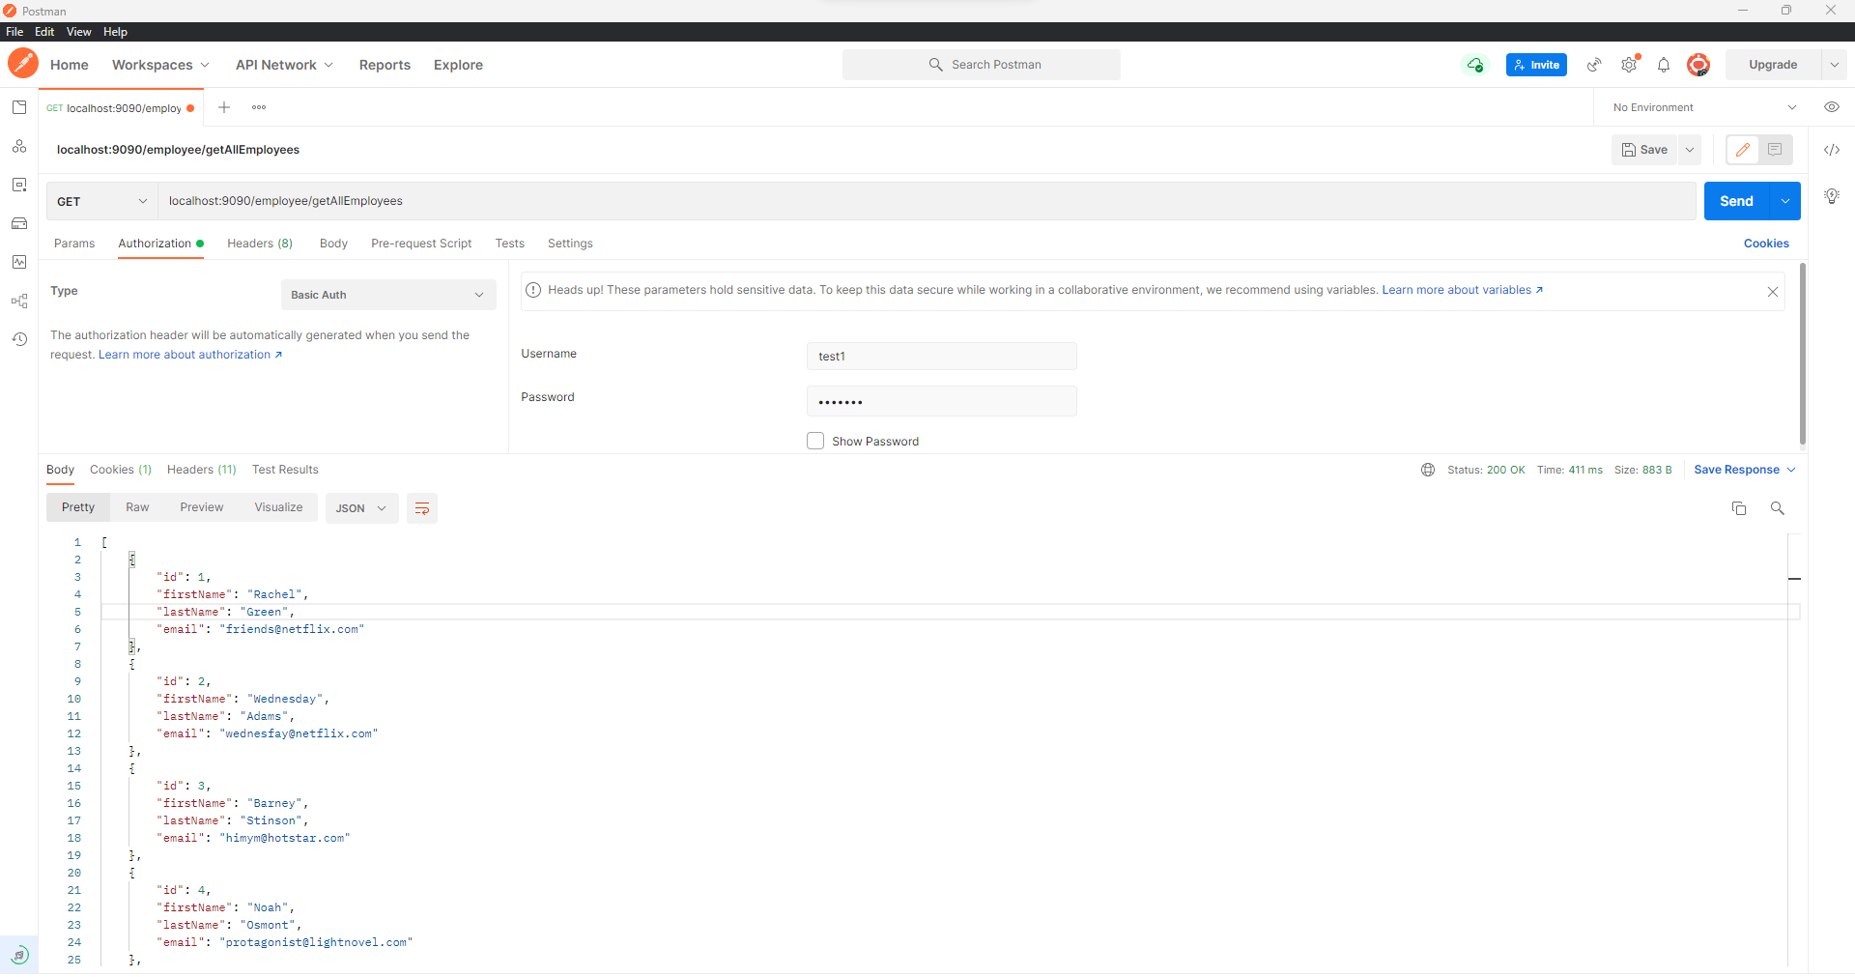
  + List employee by ID (all users)
    - localhost:9090/employee/getEmployeeById/2 (GET request)
    - Authorization: Basic auth (username: test3, password: welcome)
    - 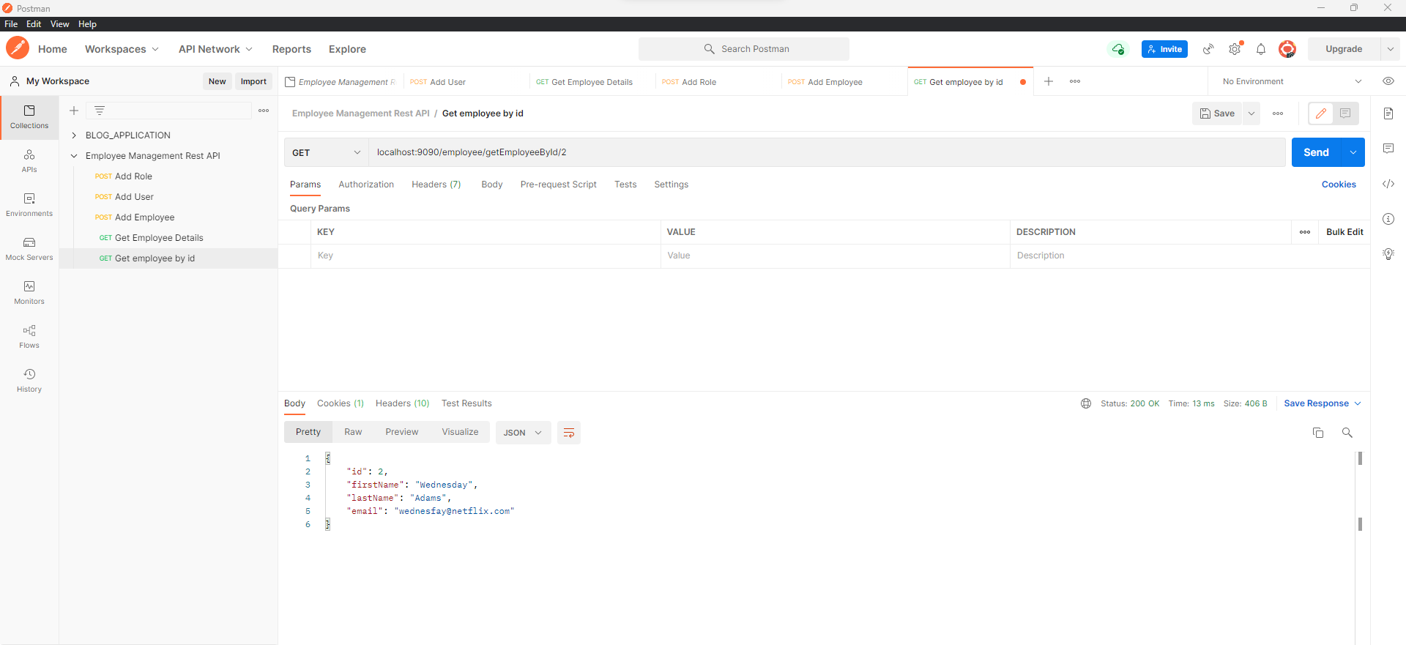
  + List employee by First name (all users)
    - localhost:9090/employee/getEmployeeByFirstname/Rachel (GET request)
    - Authorization: Basic auth (username: test3, password: welcome)
    - 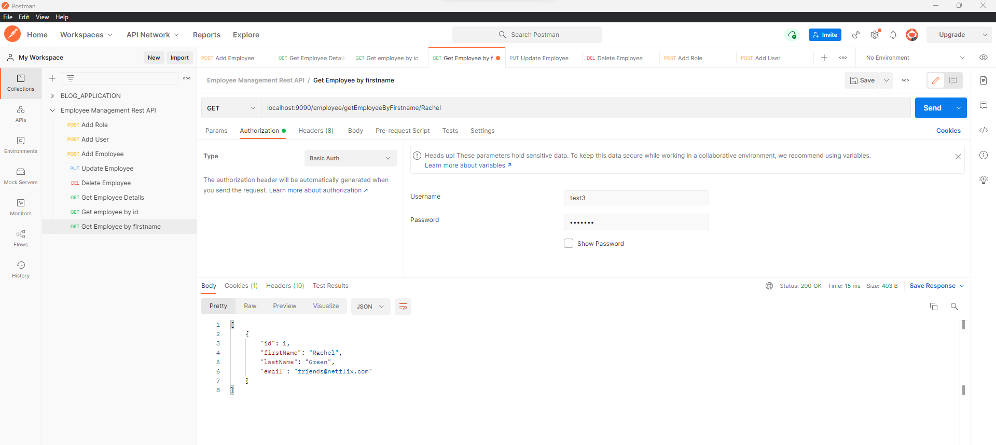
  + List employee custom sorted (all users)
    - localhost:9090/employee/getAllEmployeesCustomSorted?order=ASC (GET request)
    - Authorization: Basic auth (username: test3, password: welcome)
    - 